Module 1 –

* Understanding Linux Concepts
* What is Linux?
* Everyday use of Linux
* Unix vs. Linux

What is linux:

Linux is an operating system which sits in the middle of your hardware and the users and the users are the ones who run the applications.

So it's like a middleman or a bridge that takes the commands from users and translate them to hardware.

So look at this picture.

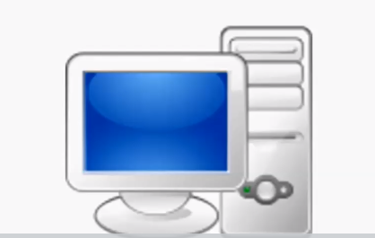

So you see a computer right.

So without an operating system this computer is considered like a dumb terminal.It doesn't do anything.So how does it work.

So we have this terminal which is of course a piece of brick.

You open the tray of their computer you insert your CD or DVD in that CD or DVD has the operating system image sitting on it whether it's a Windows or Linux or whichever operating system that you are installing. So you boot your computer from that operating system.

So once you're booting it up it goes through the installation process that installation process is going to ask you a bunch of questions like How do you want the operating system to configure how you want your dissertation.

How do you want.

How many users you want to have installed and so on.

So once the installation is done then at the end of the installation it's going to ask you to reboot

reboot the computer and it comes up to the Welcome screen and say welcome to Linux or Welcome to Windows

or whatever operating system that you are installing.

So then you could attach external devices to it.

For example you could attach a keyboard to it.

You could attach mouse to it.

So you use these mouse in keyboards you type a certain command certain you use applications and type

them and then you send it to your operating system.

Then you operate system takes those commands and forward it to other hardware or other system of peripherals.

So some of them are for example the printer.

So you if you are running an application for example you're running microsoft word you type it in with

your keyboard and then you want to print that document right.

So the operating system will take that document and send it to your printer and your printer will spit

out the document that you wanted to print.

Or if you're running other programs for example you are online you're checking your e-mail or you are

running some online program where you win games.

So you are using your keyboard or your mouse you communicating with your operating system and the heart

operating system can communicate with your hardware and that's how we make haste to other devices on

the network.

Unix vs Linux:

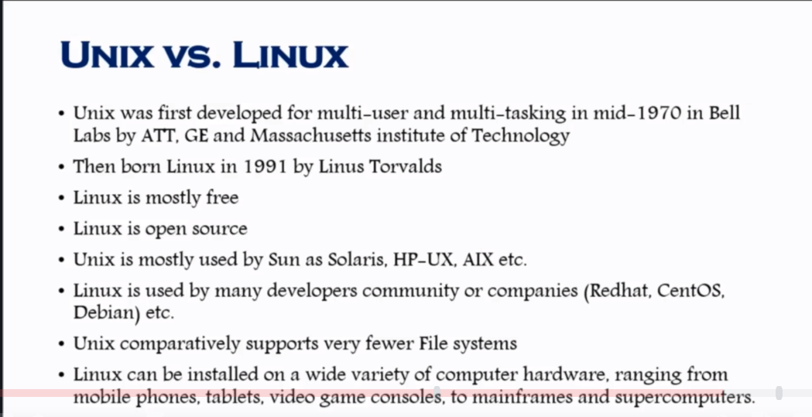

**Inside Linux**

**A) Kernel**

* The core of the UNIX system. Loaded at system start up (boot). Memory-resident control
* program.
* Manages the entire resources of the system, presenting them to you and every other user
* as a coherent system. Provides service to user applications such as device management,
* process scheduling, etc.
* Example functions performed by the kernel are:
* Managing the machine's memory and allocating it to each process.
* Scheduling the work done by the CPU so that the work of each user is carried out
* as efficiently as is possible.
* Accomplishing the transfer of data from one part of the machine to another
* Interpreting and executing instructions from the shell
* Enforcing file access permissions
* You do not need to know anything about the kernel in order to use a UNIX system. These details are provided for your information only.

**Shell**

* Whenever you login to a Unix system you are placed in a shell program. The shell's
* prompt is usually visible at the cursor's position on your screen. To get your work done,
* you enter commands at this prompt.
* The shell is a command interpreter; it takes each command and passes it to the operating
* system kernel to be acted upon. It then displays the results of this operation on your
* screen.
* Several shells are usually available on any UNIX system, each with its own strengths and
* weaknesses.
* Different users may use different shells. Initially, your system adminstrator will supply a
* default shell, which can be overridden or changed. The most commonly available shells are:

* Bourne shell (sh)

* C shell (csh)

* Korn shell (ksh)

* TC Shell (tcsh)

* Bourne Again Shell (bash)

o Each shell also includes its own programming language. Command files, called "shell

scripts" are used to accomplish a series of tasks.

**Utilities**

* UNIX provides several hundred utility programs, often referred to as commands.
* Accomplish universal functions

1. editing
2. file maintenance
3. printing
4. sorting
5. programming support
6. online info etc.

* Modular: single functions can be grouped to perform more complex tasks

**Operating system**

An operating system or OS is a software program that enables the computer hardware to communicate and operate with the computer software. Without a computer operating system, a computer and software programs would be useless.

An operating system (sometimes abbreviated as "OS") is the program that, after being initially loaded into the computer by a boot program, manages all the other programs in a computer. The other programs are called applications or application programs. The application programs make use of the operating system by making requests for services through a defined application program interface (API). In addition, users can interact directly with the operating system through a user interface such as a command language or a graphical user interface (GUI).

An operating system performs these services for applications:

* In a multitasking operating system where multiple programs can be running at the same time,
* the operating system determines which applications should run in what order and how much
* time should be allowed for each application before giving another application a turn.
* It manages the sharing of internal memory among multiple applications.
* It handles input and output to and from attached hardware devices, such as hard disks, printers,
* and dial-up ports.
* It sends messages to each application or interactive user (or to a system operator) about the status
* of operation and any errors that may have occurred.
* It can offload the management of what are called batch jobs (for example, printing) so that the
* initiating application is freed from this work.
* On computers that can provide parallel processing, an operating system can manage how to
* divide the program so that it runs on more than one processor at a time.

Examples of computer operating systems

* Redhat – Very popular Linux operating system from Redhat
* Microsoft Windows - PC and IBM compatible operating system. Microsoft Windows is the most
* commonly found and used operating system in PCs
* Apple MacOS - Apple computer operating system. The only Apple computer operating system.
* Ubuntu Linux - A popular variant of Linux used with PC and IBM compatible computers.
* Google Android - operating system used with Android compatible phones.
* iOS - Operating system used with the Apple iPhone.

**Module 2**

* What is Oracle Virtual Box?
* Downloading and Installing Oracle Virtual Box
* Creating virtual machine
* Linux Distributions
* Different way to install Linux
* Downloading and Installing Linux (CentOS)
* Redhat Linux installation (Optional)
* Linux Desktop (GUI)
* Virtual Machine Management
* Linux vs. Windows
* Who Uses Linux?

What is Oracle Virtual Box?

Oracle virtual box is is a virtual environment which allows you to run a multiple operating system on the same hardware.

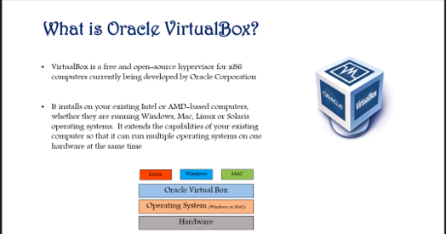

Oracle Virtual Box installation